CHAPTER TWO

LITERATURE REVIEW

2.1 Conceptual Framework
The hierarchical network design model, often referred to as the three-tier model, was popularized by Cisco Systems and has become the standard approach for designing enterprise networks. According to Tanenbaum and Wetherall (2011), hierarchical models simplify network design by breaking large, complex systems into smaller, manageable layers with well-defined roles and responsibilities.
2.1.1 The three layers are:
- Core Layer: This is the backbone of the network. Its primary function is to provide fast, reliable transportation of data between distribution layer devices. The core layer is optimized for high-speed switching and routing. Redundancy is critical at this layer, as failure here affects all parts of the network. Devices at the core layer are typically high-performance routers or multilayer switches.
- Distribution Layer: This layer serves as an aggregation point for the access layer and enforces policies such as routing, filtering, and Quality of service. It connects the access layer to the core and handles inter VLAN routing, and traffic management. Multilayer switches or routers are commonly deployed here.
- Access Layer: This is the point at which end devices such as PCs, printers, and IP phones connect to the network. Access layer switches enforce security policies, provide VLAN segmentation, and support Power over Ethernet (PoE). Port security and STP are commonly configured at this layer.

The benefits of the hierarchical model include; Modularity (each layer can be upgraded independently), scalability (the network can grow without redesigning the whole architecture), and manageability (each layer has a distinct function, making troubleshooting more straightforward).

2.1.2 Open Shortest Path First (OSPF)
OSPF is a link-state routing protocol defined in RFC 2328 by the Internet Engineering Task Force (IETF). Unlike distance-vector protocols such as RIP, OSPF maintains a complete topological map of the network in a database called the Link-State Database (LSDB). Each router exchanges Link State Advertisements with its neighbors to populate this database, and then independently runs Dijkstra's SPF algorithm to compute the shortest path to each destination.
OSPF supports a two-level hierarchical structure of its own: the backbone area (Area 0) and non-backbone areas. All non-backbone areas must connect to Area 0, either directly or through virtual links. This design reduces LSA flooding and limits the size of routing tables within each area. Area Border Routers (ABR) connect multiple areas and summarize routing information between them.
2.1.2.1 Key OSPF concepts include:
- Router ID: A unique 32-bit identifier for each OSPF router, usually the highest IP address on a loop-back interface.
- Hello Protocol: OSPF routers discover neighbors by exchanging Hello packets. Adjacencies are formed when parameters such as Hello/Dead intervals, Area ID, and authentication match.
- Designated Router (DR) and Backup Designated Router (BDR): On multi-access networks (e.g., Ethernet), OSPF elects a DR and BDR to reduce the number of LSA exchanges. All routers form adjacency only with the DR and BDR.
- OSPF Cost: The metric used by OSPF is called cost, calculated as 100 Mbps divided by the interface bandwidth. Lower cost paths are preferred.
- OSPF States: Routers transition through several states when forming adjacency: Down, Attempt, Init, 2-Way, ExStart, Exchange, Loading, and Full.

2.1.3 Point-to-Point Protocol (PPP)
PPP is a Layer 2 protocol standardized in RFC 1661. It is designed to encapsulate network layer packets over serial point-to-point links, providing a standardized method for two directly connected devices to communicate. PPP replaced the older SLIP (Serial Line Internet Protocol) due to its richer feature set, which includes:
- Multi-protocol support: PPP can carry multiple network layer protocols such as IP, IPX, and Apple Talk simultaneously.
- Error detection: PPP uses a 16-bit CRC for error checking.
- Authentication: PPP supports PAP (Password Authentication Protocol) and CHAP (Challenge Handshake Authentication Protocol). PAP sends credentials in plaintext, while CHAP uses MD5 hashing for a more secure exchange.
- Link Control Protocol (LCP): Used to establish, configure, and test the data link connection.
- Network Control Protocol (NCP): Used to establish and configure different network layer protocols.
CHAP authentication works through a three-step process:
- The authenticator sends a challenge message
- The peer responds with a hash value computed using the challenge and a shared secret, and
- The authenticator compares the response with its own computation. If they match, access is granted.

2.1.4 Spanning Tree Protocol (STP)
STP was developed by Radia Perlman in 1985 and later standardized as IEEE 802.1D. Its fundamental purpose is to prevent Layer 2 loops in networks with redundant paths. Without STP, a broadcast frame entering a loop would be forwarded indefinitely, saturating all network bandwidth and causing a broadcast storm.
STP operates by electing a Root Bridge, which becomes the logical center of the spanning tree. All other switches compute a shortest path to the root bridge and block any redundant paths. The STP process involves:
- Root Bridge Election: The switch with the lowest Bridge Identifier (BID), composed of a priority value (default 32768) and the switch's MAC address, is elected as the root bridge.
- Root Port Selection: Each non-root switch selects a Root Port, which is the port with the lowest cost path to the root bridge.
- Designated Port Selection: On each network segment, the switch with the lowest path cost to the root bridge has its port designated as the Designated Port.
- Port States: STP ports transition through Blocking, Listening, Learning, and Forwarding states. Convergence to the Forwarding state can take up to 50 seconds in standard STP (IEEE 802.1D).
Rapid Spanning Tree Protocol (RSTP), defined in IEEE 802.1w, improves convergence time to less than one second by introducing new port roles and eliminating some of the listening and learning states.

2.2 Theoretical Framework

2.2.1 OSI Reference Model
The Open Systems Interconnection (OSI) model, developed by the International Organization for Standardization (ISO), provides a conceptual framework for understanding how different network protocols interact. It consists of seven layers: Physical, Data Link, Network, Transport, Session, Presentation, and Application. The protocols discussed in this project operate at different OSI layers. Understanding the OSI model helps engineers troubleshoot by isolating problems to a specific layer, ensuring the correct protocol is examined.

Protocol | OSI Layer | Function
STP | Layer 2 (Data Link) | Loop prevention in switched networks
PPP | Layer 2 (Data Link) | WAN encapsulation and authentication
OSPF | Layer 3 (Network) | Dynamic routing and path selection
IP | Layer 3 (Network) | Logical addressing and packet forwarding
Ethernet | Layer 2 (Data Link) | Frame transmission on LAN links

2.2.2 Network Convergence Theory
Network convergence refers to the time it takes for all routers or switches in a network to agree on a consistent view of the topology after a change (such as a link failure). Fast convergence is critical for minimizing service disruption. OSPF achieves relatively fast convergence compared to distance-vector protocols because it floods link state changes throughout the area immediately upon detection. STP convergence in its original 802.1D form is slow (30-50 seconds), which motivated the development of RSTP and other improvements.

2.2.3 Redundancy and Fault Tolerance
Redundancy in network design refers to the use of multiple paths, devices, or links so that a single failure does not bring down the entire network. However, redundancy at Layer 2 (switches) without STP creates loops. Redundancy at Layer 3 (routers) is handled by OSPF ability to route around failed links. The interplay between STP and OSPF in a hierarchical design ensures both Layer 2 and Layer 3 redundancy operate correctly without interference.
2.3 Empirical Literature

2.3.1 Related Studies
Oluwadare and Babatunde (2019) conducted a study on OSPF performance in a simulated enterprise network using Cisco Packet Tracer. Their findings showed that OSPF converged faster than RIP in networks with more than 10 routers and provided more accurate routing in the presence of multiple paths. They recommended OSPF for any network with more than two routers.
Musa et al. (2020) compared different WAN encapsulation protocols including PPP and HDLC in a simulated environment. Their results showed that PPP with CHAP authentication provided a significantly more secure connection than HDLC or PPP without authentication, with negligible performance overhead. They concluded that CHAP should be the default configuration for all PPP serial links in security-sensitive environments.
Eze and Nwachukwu (2021) investigated the impact of STP on network performance in a topology with multiple switches and redundant paths. Their simulation demonstrated that enabling STP eliminated all broadcast loops within 45 seconds of network startup, while RSTP reduced this to under 2 seconds. The study recommended RSTP over legacy STP for modern enterprise deployments.
Abubakar et al. (2022) designed a hierarchical campus network for a Nigerian university using Cisco Packet Tracer, integrating OSPF and VLANs. Their study highlighted that the hierarchical model improved traffic management and allowed network administrators to isolate faults more efficiently than a flat design. They also noted that proper IP addressing and OSPF area planning were critical success factors.
These empirical works collectively support the design choices made in this project: using OSPF for dynamic routing, PPP with CHAP for secure WAN links, and STP for loop-free switching. They also validate the use of Cisco Packet Tracer as a reliable simulation tool for undergraduate network projects.

2.3.2 Gap in the Literature
Despite the extensive literature on individual protocols, few studies have documented the simultaneous integration of OSPF, PPP, and STP within a single hierarchical network model with step-by-step configuration commands and verification outputs. Most existing works focus on one protocol at a time or use flat topology. This project fills that gap by providing an end-to-end, multi-protocol hierarchical network implementation, complete with configuration steps and verification evidence.
CHAPTER THERR

METHODOLOGY AND DESIGN

3.1 Methodology
This project follows the Network Development Life Cycle (NDLC), a structured methodology for planning, designing, implementing, and operating network systems. The NDLC consists of the following phases:
- Analysis Phase: Requirements were gathered by identifying the network's functional goals, including the number of users, device types, routing requirements, WAN connectivity, and redundancy needs. The three-tier hierarchical model was selected as the architectural framework.
- Design Phase: Based on the requirements, a logical network topology was created. IP addressing schemes were planned for all interfaces, sub-nets were allocated for each layer, and protocol parameters were determined for OSPF, PPP, and STP.
- Simulation Phase: The physical and logical topology was constructed in Cisco Packet Tracer. All devices were placed, connected with appropriate cable types, and assigned IP addresses.
- Configuration Phase: Each device was configured via its CLI (Command Line Interface). OSPF was configured on all routers, PPP with CHAP was configured on serial links, and STP was configured on all switches.
- Verification Phase: The network was tested using Cisco IOS show commands and connectivity tests (ping and trace route) to verify that the protocols were functioning correctly.
- Documentation Phase: All configuration steps, commands, and outputs were documented with screenshots and explanations.
This iterative approach ensures that each phase builds on the previous one, and problems identified during verification are fed back into the design or configuration phases for correction.

3.2 Tools and Software
Tool/software | version | purpose
Cisco packet tracer | 9.0.0.0910 | Primary networking simulation environment
Microsoft word/WPS | 2013 | Project documentation
Cisco IOS | 9.0.0.0810 | Router switches operating system
Windows 10 pro OS | 10.0.0.19045 | Host operating system for simulation

3.2.1 Justification for Cisco Packet Tracer
Cisco Packet Tracer was selected as the primary simulation tool for the following reasons:
- It is freely available to students through the Cisco Networking Academy.
- It supports all required Cisco IOS commands for OSPF, PPP, and STP configuration.
- It provides a visual, drag-and-drop interface for topology design.
- It allows real-time simulation and observation of packet flows.
- It is widely recognized in academic and professional circles as a valid network design tool.

3.3 Network Specifications

3.3.1 Device Inventory
DEVICE | MODEL | QUANTITY | LAYER | ROLE
Router | Cisco 2911 | 2 | Core | OSPF routing, PPP WAN links
Multilayer-Switch | Cisco 3560 | 2 | Distribution | Inter-VLAN routing, OSPF
Access Switch | Cisco 2960 | 4 | Access | STP, VLAN access
pc EndDevices | Generic Pc | 16 | Access | End-user simulation
Server | Server-PT | 1 | Core | DNS/Web simulation

3.4 Project Timeline (Gantt Chart)
The following table represents the project timeline over a 127-days period:
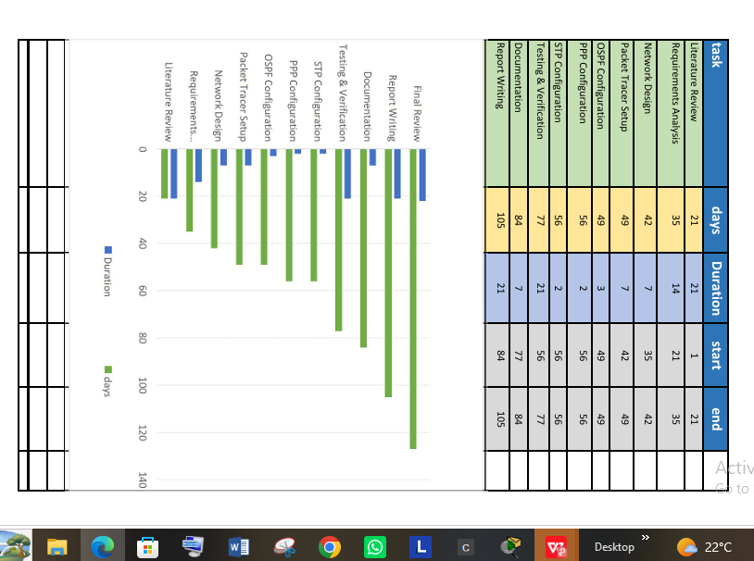

CHAPTER FOUR

IMPLEMENTATION

